PORT ELIZABETH KENNEL CLUB NEWS LETTER
MAY 2011
With all our big shows behind us for now, and still lots to come in the next couple of months, I urge you to please send me any achievements your dogs get, so this can be put in the news letter.
I have not received any news from members; this makes the job of writing a news letter very hard. At the April Carting shows two of our E.P. Carters were awarded with their Provincial Colours. They were Joan Saward Dumbris and Kazi and Carly-Anne Mostert with Storm. Well done to you both, we are proud of you! To all the other carters, well done on your achievements.
No news from the Breed Ring sent in and all I can report here is that Carly-Anne Mostert and Artaz got 3cc in the Herding Group. This was their first breed show, well done!! To all the other competitors well done on your achievements as well.
No news from Jumping and Agility and none from the Obedience. Port Elizabeth Kennel Club got a lot of feed back and congratulations on show well run, thanks to all who made this possible with your time and hard work and especially to John and Daphne. Want to just mention to those who didn’t know Tracey Wild did our CC Certificates and ran the computer programme for P.E.K.C. and did a fantastic job! THANKS TRACEY!!!!! To Janet our secretary, thanks for all your hard work and effort put into the show.
Well that’s about all I can say for now, please help get this letter back into circulation by sending me news. My new email address if bridget@igen.co.za looking forward to hearing from you all.
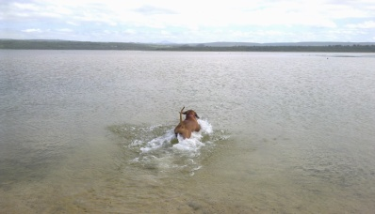
With warm woofing regards
Max and Blade on the beach!!!

